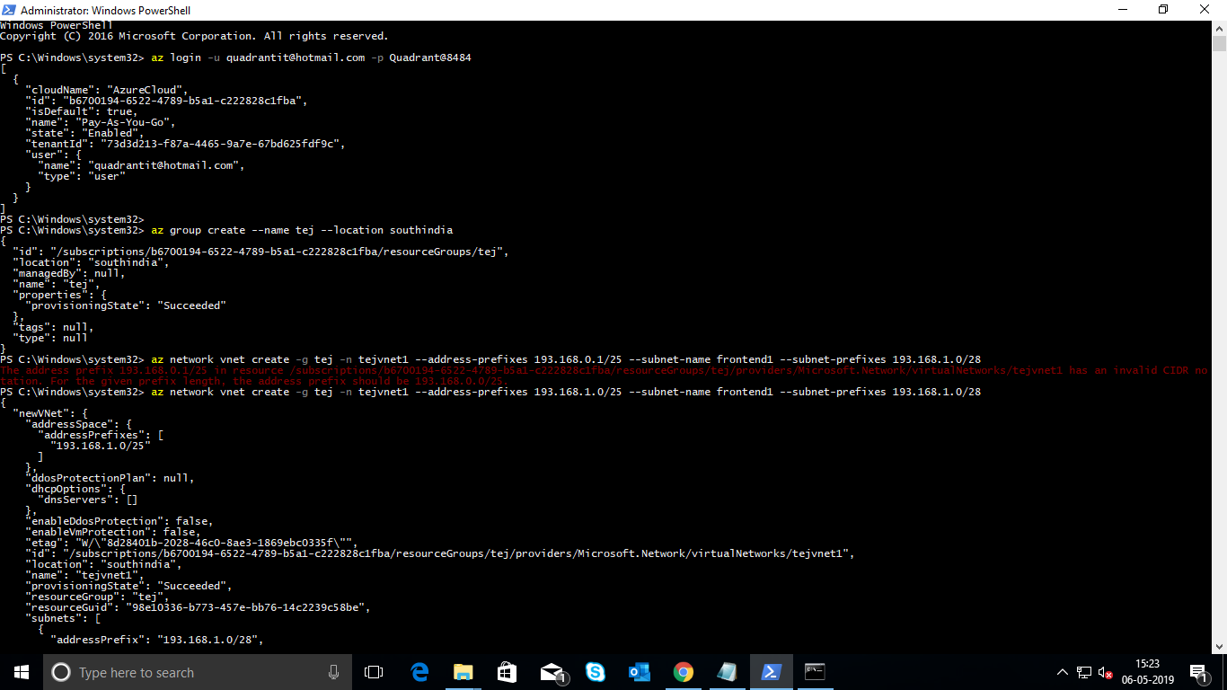

Created a resource group

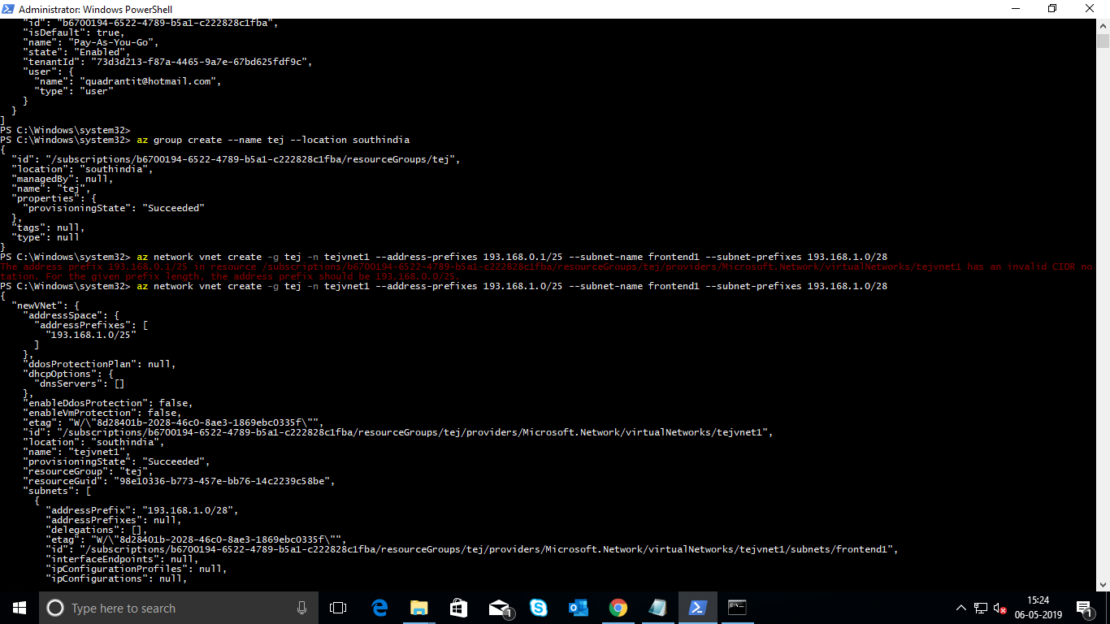

Created a vnet and subnet frontend1

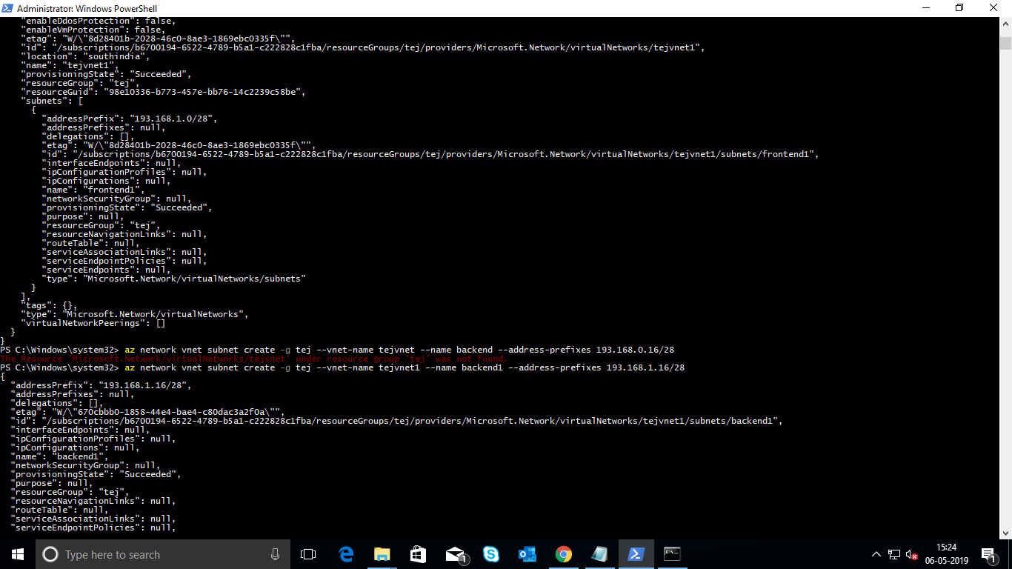

Created a subnet backend1

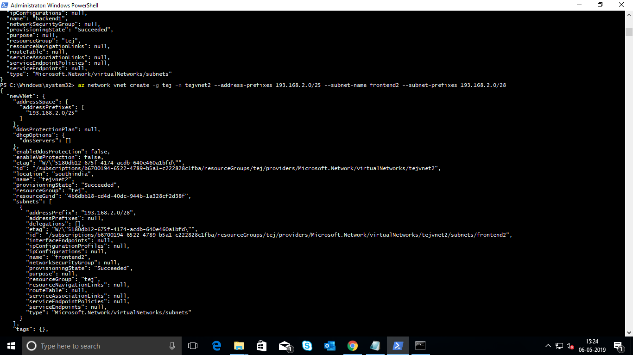

Created a vnet and subnet frontend 2

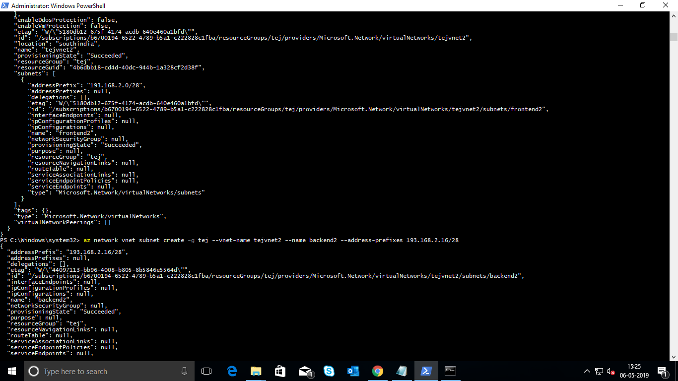

Created a subnet backend2

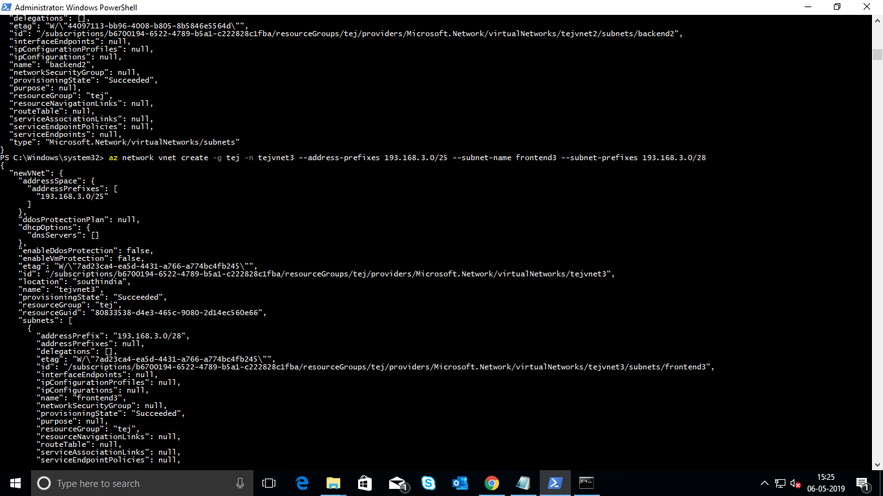

Created a vnet and subnet frontend 3

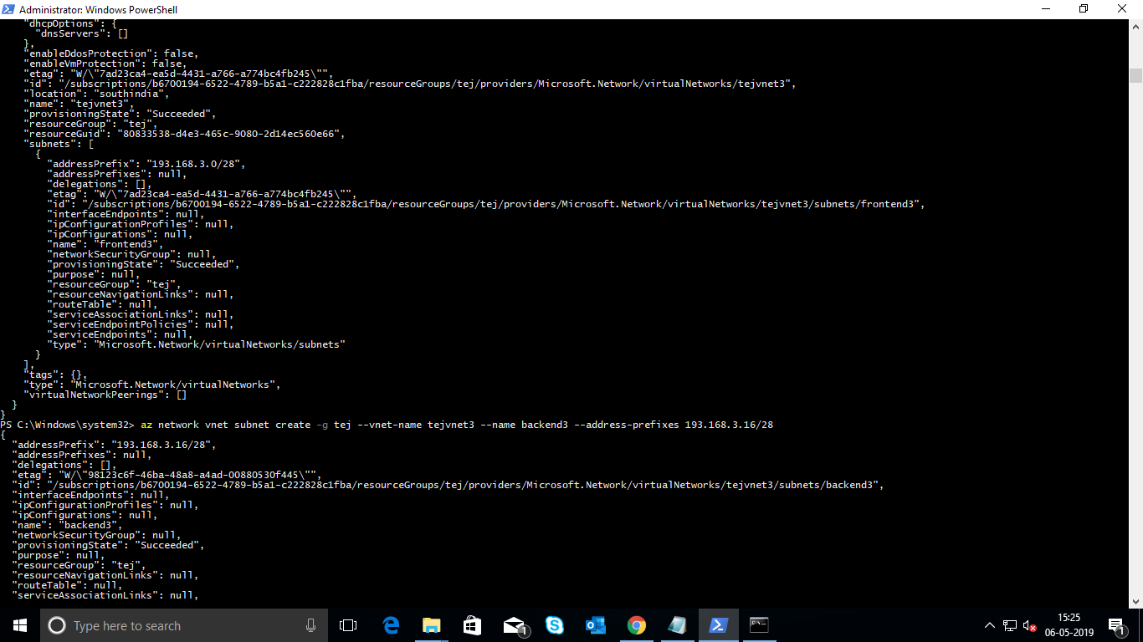

Created a subnet backend 3

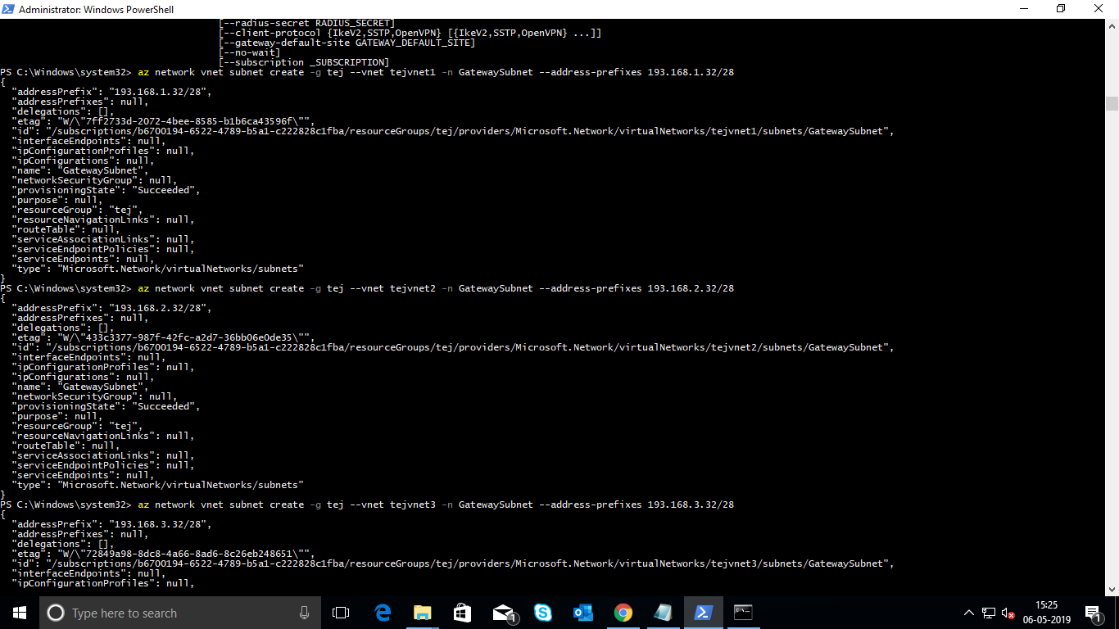

Created a gateway subnets 1, 2 and 3

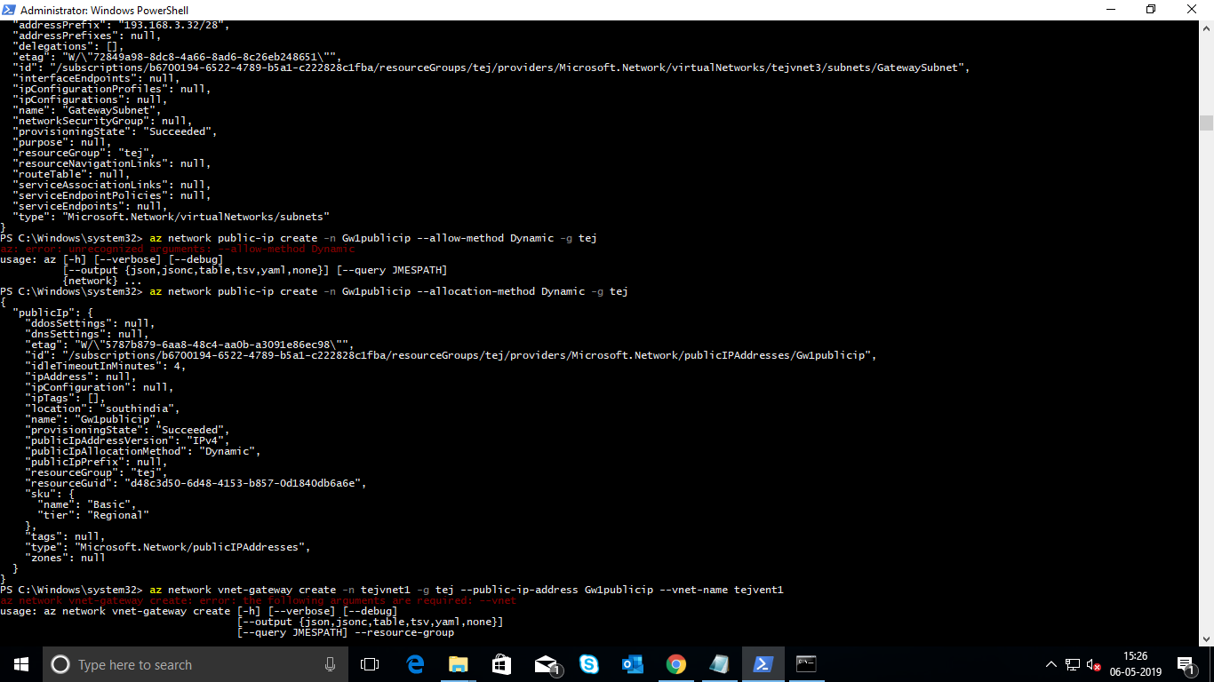

Created a public ip address VPN gateway 1

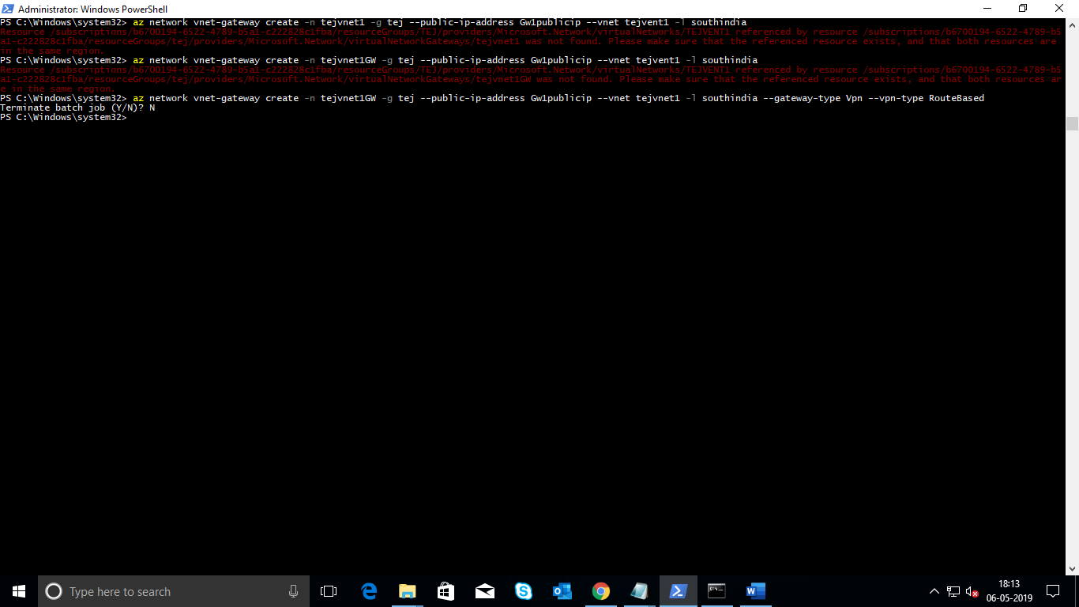

Created a VPN gateway1

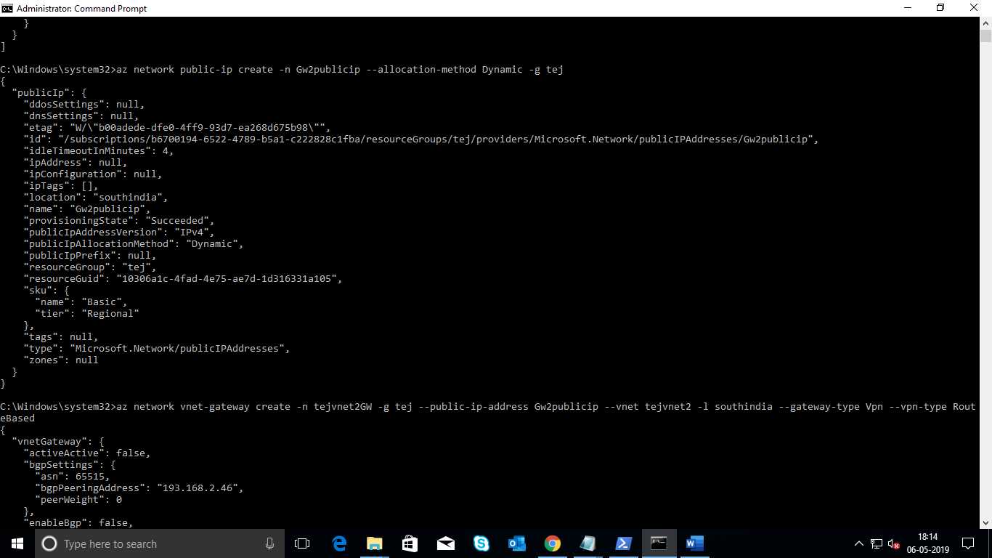

Created a public ip address VPN gateway2

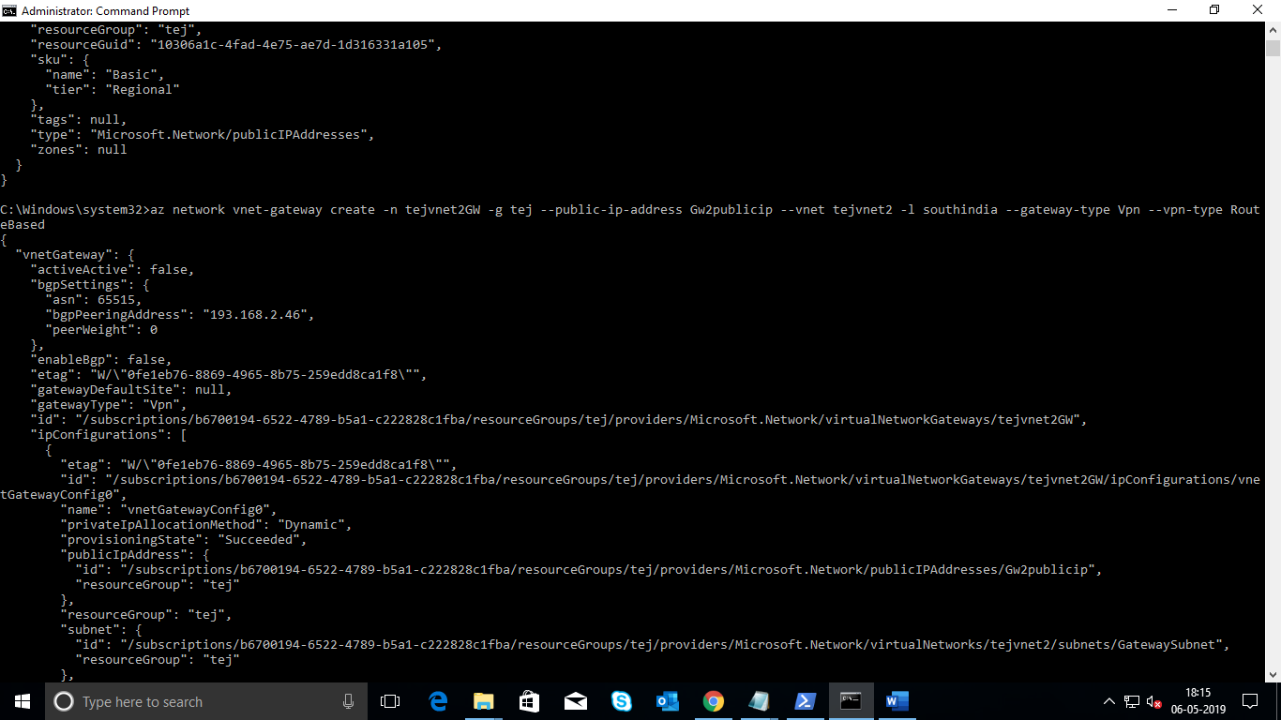

Created a VPN Gateway2

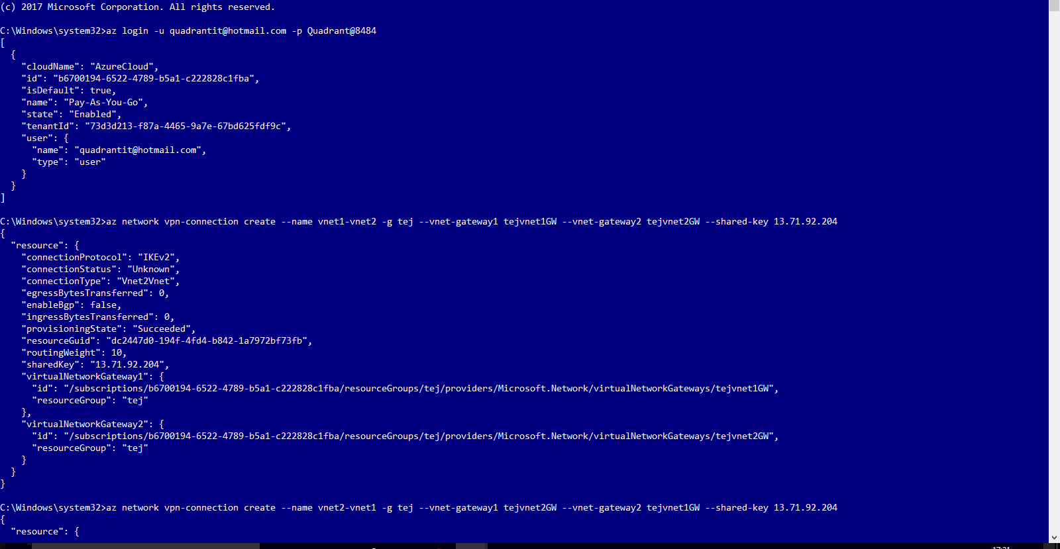

Connection Vnet 1 to Vnet 2

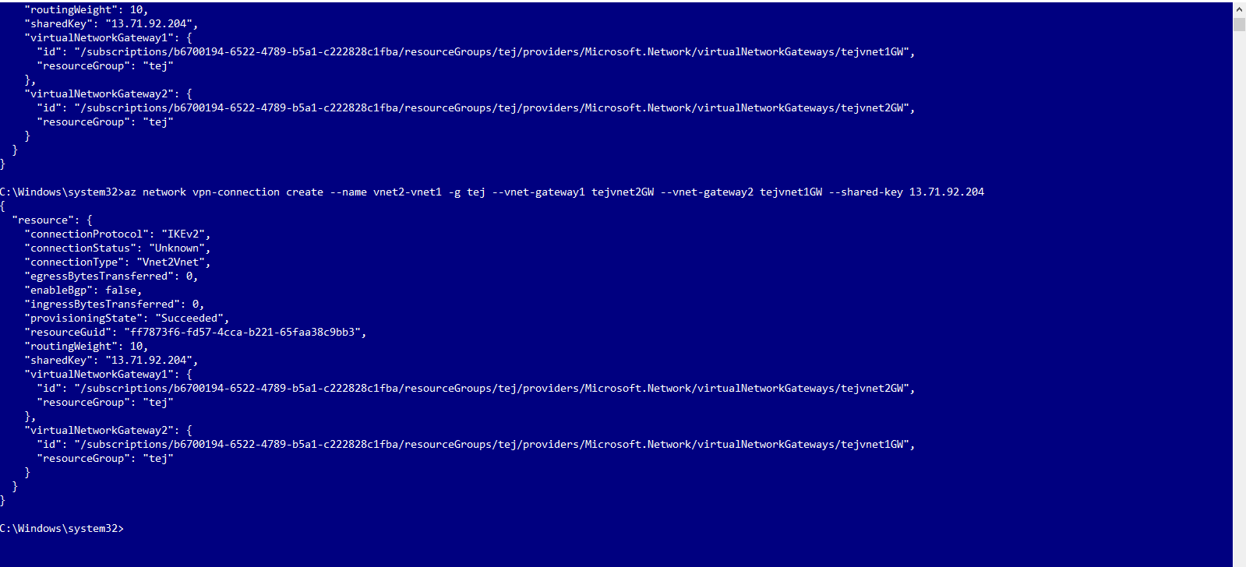

Connection Vnet2 to Vnet1

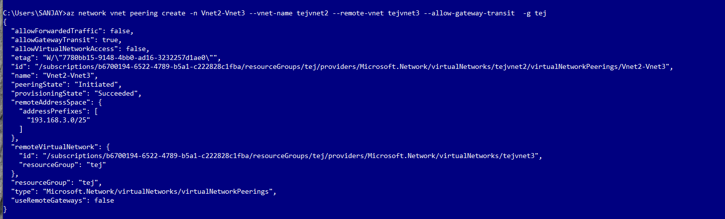

Connecting peering Vnet2 to Vnet3

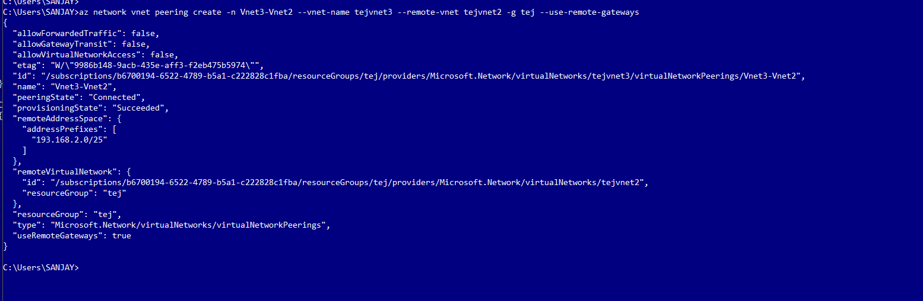

Connecting peering Vnet3 to Vnet2